Exercise No. 5a
Name: Sweta.S.K
Roll No: 240701549
Simulate the Lifecycle Stages for UI Design Using the RAD Model
and Develop a Small Interactive Interface Using Axure RP
AIM:
The aim is to demonstrate the lifecycle stages of UI design via the RAD model and develop a small interactive Music App interface employing Axure RP.

PROCEDURE:
Tool Link: https://www.axure.com/

Simulating the Lifecycle Stages for UI Design Using the RAD Model
RAD Model (Rapid Application Development): The RAD model emphasizes quick development and iteration. It consists of the following phases:

1. Requirements Planning
- Gather initial requirements and identify key features of the Music App UI.
- Engage stakeholders to understand their needs and expectations.
- Key features identified: Home Screen, Browse Music, Search, Playlist view, and Music playback navigation.

2. User Design
- Create initial prototypes and wireframes of the Music App screens.
- Conduct user feedback sessions to refine the designs.
- Use Axure RP to develop interactive prototypes with navigation between screens.

3. Construction
- Develop the actual UI based on the refined designs.
- Perform iterative testing and feedback cycles.
- Add interactions for button clicks, search, and playlist navigation.

4. Cutover
- Deploy the final UI.
- Conduct user training and support.

Axure RP Interactive Interface Development — Music App

Phase 1: Requirements Planning
1. Identify Key Features:
- Navigation (Home, Browse Music, Search, View Playlist)
- User actions (Listen to New Music, Search Music, View Playlist, Go Back)
- Interactive elements: Buttons, Search bar, Music list with play icons

2. Create a Requirements Document:
- List all features and functionalities of the Music App.
- Document user stories and use cases for each screen.

Phase 2: User Design
1. Install and Launch Axure RP:
- Download and install Axure RP from Axure's official website.
- Launch the application.

2. Create a New Project:
- Go to File → New to create a new project.
- Name the project (e.g., "Music App Interface").

3. Create Wireframes:
- Use the widget library to drag and drop elements onto the canvas.
- Design wireframes for each screen:
  - Home Screen (Music App title, music note icon, Listen to New Music button, View Playlist button)
  - Browse Music Screen (Search bar, Music 1/2/3 list with play icons, Go Back button)
  - My Playlist Screen (Playlist header, Music 1/2/3 list, Go Back button, Listen to New Music button)

4. Add Interactions:
- Select an element (e.g., 'Listen to New Music' button) and go to the Properties panel.
- Click on Interactions and choose an interaction (e.g., OnClick).
- Define the action (e.g., navigate to Browse Music screen).
- Similarly, link 'View Playlist' button to the My Playlist screen.
- Add 'Go Back' interactions to return to the Home Screen.

5. Create Masters:
- Create reusable components (e.g., bottom navigation bar with Go Back, Search, View Playlist) using Masters.
- Drag and drop masters onto the wireframes for consistency.

6. Add Annotations:
- Add notes to describe each element's purpose and functionality.
- Use the Notes panel to add detailed annotations for each screen and interaction.

Phase 3: Construction
1. Develop Interactive Prototypes:
- Convert wireframes into interactive prototypes by adding interactions and transitions.
- Use dynamic panels to create interactive elements (e.g., search functionality, pop-ups).

2. Test and Iterate:
- Preview the prototype using the Preview button.
- Gather feedback from users and stakeholders.
- Make necessary adjustments based on feedback.

Phase 4: Cutover
1. Finalize and Export:
- Finalize the design and all interactions across the three screens.
- Export the prototype as an HTML file or share it via Axure Cloud.

2. User Training and Support:
- Conduct training sessions to familiarize users with the new Music App interface.
- Provide documentation and support for any issues.

Screenshots of the Music App Prototype
The following screens were designed and prototyped using Axure RP:

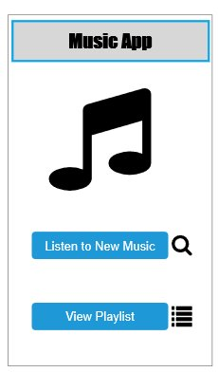  Screen 1: Home Screen | 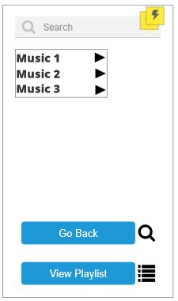  Screen 2: Browse Music | 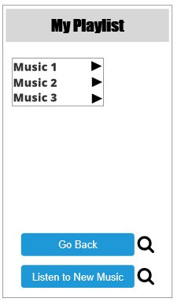  Screen 3: My Playlist

Screen Descriptions:
- Screen 1 – Home Screen: Displays the Music App title, a music note icon, and two action buttons — 'Listen to New Music' (navigates to Browse screen) and 'View Playlist' (navigates to Playlist screen).
- Screen 2 – Browse Music: Contains a search bar at the top, a music list (Music 1, Music 2, Music 3) with play icons, a 'Go Back' button to return to Home, and a 'View Playlist' button.
- Screen 3 – My Playlist: Shows the 'My Playlist' header, the saved music list, a 'Go Back' button, and a 'Listen to New Music' button to return to Browse.

RESULT:
The lifecycle stages of UI design using the RAD model were successfully simulated. A small interactive Music App prototype with three interconnected screens was developed using Axure RP, demonstrating requirements planning, user design, construction, and cutover phases.

